COME ON, OUT NOW…

After months of indoor living, it's time to put on your traveling shoes without forgetting your masks and go on a vacation. It’s no doubt that this country alone offers you a lot of choices. Go knocking around at the doors of one and the many cities of **North India**. We have narrowed down your options to Top 4 places to hit the road early this year.

1. Leh, Ladakh

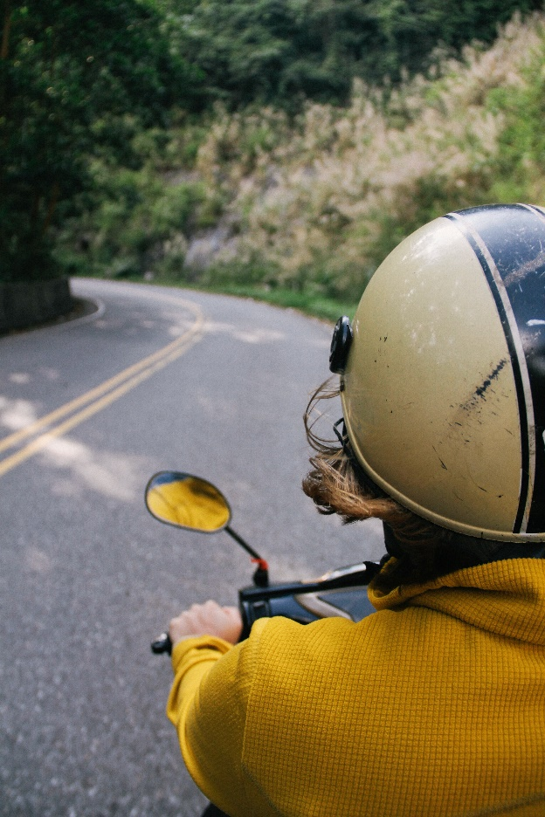

**Beginning from the high altitudes of India, set amidst the epic Himalayas is the rustic, beautiful, and heavenly world of Ladakh**. **Surrounded by the towering peaks of Ladakh range, the southern-east extension range of Karakoram Pass is the town of Leh- featuring a unique combination of landscapes, cultures, and lifestyles. The culture of Leh is similar to that of Tibet because of the obvious regional proximity**. The serene scenes in the Autumn of Leh offer a variety of sites to watch out for like:

* Shanti stupa
* Namgyal Tsempo Monastery
* Shey Monastery,
* Hemis monastery

**Apart from the many monasteries scattered in and around Leh, other must-visit sites include:**

* The Leh Palace
* Hall of Fame Museum
* The Leh Market- a place for you to find souvenirs for family and friends.

**CUISINE**

Any travel description is not in its full spirit without giving a taste of the regional cuisines.

* Thukpa is a noodle soup dish often found in every restaurant of Leh.
* Butter tea with a loaf of Khambir- a traditional bread is a local preference and a must-have.
* Mokthuk- a superb blend of momos and soup is enjoyed particularly by kids.
* Chhupri or yak cheese is made from Yak’s milk by churning it and adding lime and other citrus fruits. It is easily available in the local bakeries of the area.
* Chang prepared by fermenting miller with yeast is a popular, local beverage.

**Leh is filled with zest even if you do nothing, but just sit at one place and enjoy the calmness of the river flowing. You are surely in for a treat and a memorable trip with your friends and family.**



Kaza, Himachal Pradesh

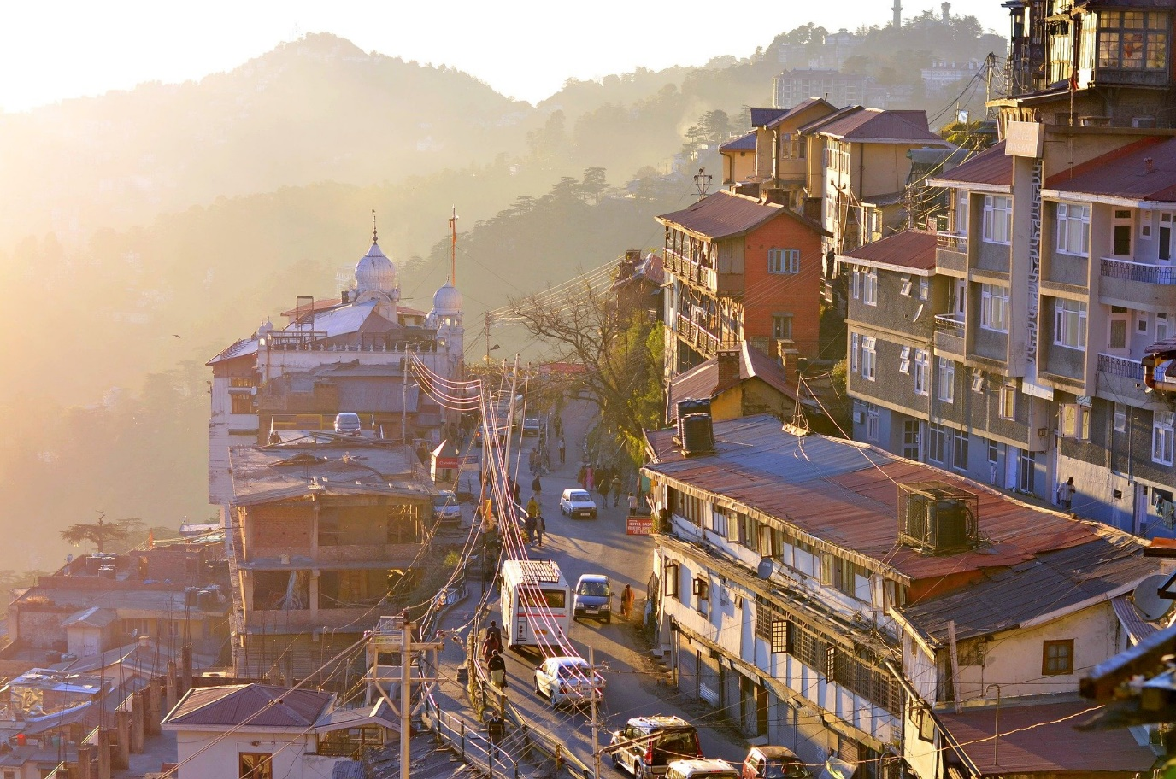

**Overlooked by high mountain ridges from all sides is the township of Kaza in Himachal Pradesh. This region will show you several natural rock formations, snow-capped mountain peaks, deep gorges, traditional Spitian villages, ancient Buddhist Monasteries, everything beautiful**. Kaza is an active Summer Spirit with:

* Colorful festivals like Fagli, Gochi, and the world-famous Ladarcha Fair.
* Kibber Village- the highest motor-able village in the world.
* Kibbe Wildlife sanctuary is also a site to check out.
* The Ki Monastery or the Ki Gompa- the biggest training center of Lamas.
* The infamous Tabo Monastery hosting interesting festivals.
* Often called the gateway to Kaza, Kunzum Pass is situated at a height of 4551m and has a temple situated at the top of the pass with a belief of protection.

**CUISINE**

With so much to see, this place also offers a lot to eat. We recommend a few items here :

* Dhaam is a local delicacy.
* Bhey is a unique dish made with lotus stems and is an addictive part of **Lahaul and Spiti food.**
* Chhaa Gosht is a rich mountain delicacy for meat lovers.
* Aktori is a festive **local food of Spiti Valley** made with buckwheat leaves and is shaped like a pancake or cake.
* Chaza is a salty tea is made with melted yak butter.
* Seabuckthorn Juice is made from the wonder berries of the Himalayas, also known as Leh Berries.

The food palate and the spectacle in Himachal are so rich that they leave every traveler awed. Bring your loved ones and experience the beauty of this place.



Pitthoragarh, Uttarakhand

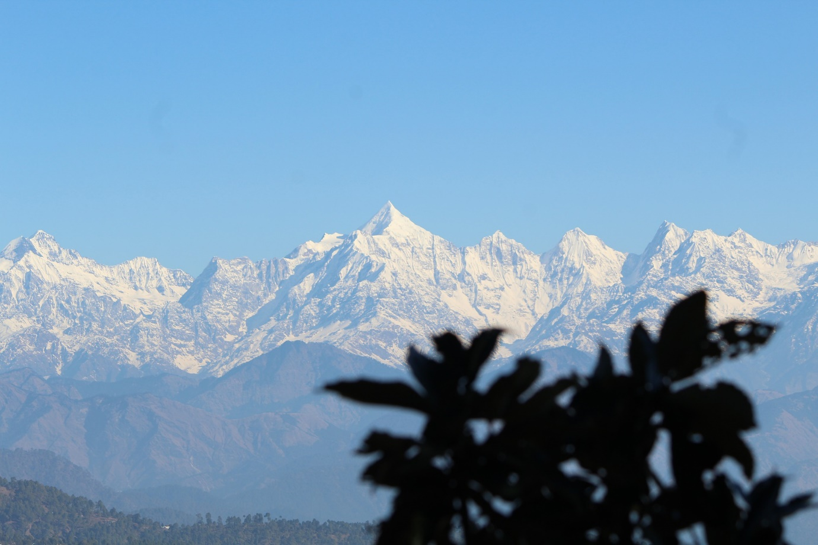

**In the easternmost district of Uttarakhand, Pithoragarh is often called the mini-Kashmir of Uttarakhand for its exquisite beauty of high Himalayan peaks, waterfalls, glaciers, and nature all around. The town is a hub for adventure activities like paragliding and trekking, along with being a gateway for the sacred Hindu pilgrimage of Kailash Mansarovar.**

Along with relishing the views of the enchanting mountains in the Summers, you can also see:

* The glaciers and alpine valleys like Ralam, Milam, Sundardunga, and Namik.
* The Pithoragarh fort holding this city’s history.
* Temples dedicated to Lord Shiva such as the cave-shaped Kapileshwar Temple and Nag Mandir sculpted in the form of a snake.
* Panchachuli Peaks which include Nanda Devi and Nandakot.

**CUISINE**

As for the food, there are plenty of restaurants and roadside dhabas pepper all over Pithoragarh that would offer delicious food. But you can also try the classic Kumauni dishes like:

* Lentil-based Gahat Dal, Chainsoo, Dubuk.
* Curry-based Kafuli, Sisunaak Saag
* Popular sweets like khoa-based Bal Mithai and Singauri.

**Pithoragarh is a visual treat for the kids and adults alike. It is the perfect place to bring your family and experience the serenity it offers.**



Gangtok, Sikkim

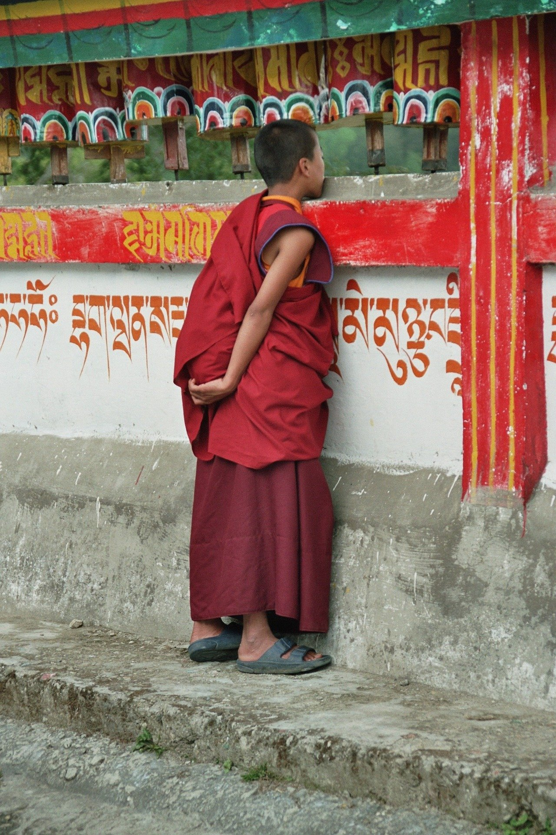

**The capital city of Sikkim has plenty to offer you on tour. In sync with the Zen philosophy, Gangtok is an epitome of neatness and is one of the few such places in India. It is a city of awe-inspiring sceneries, austere mountains, rich insight into the Buddhist culture and monasteries, great food, and serenity personified**. Many sites in Gangtok will leave you awe-struck such as:

* Mt. Kanchenjunga towers high above the other peaks of Sikkim and can be glimpsed from most places around Gangtok.
* The Tsomgo Changu Lake is a glacial lake with breath-taking beauty.
* The infamous Nathu La Pass connects Sikkim with China’s Tibet Autonomous Region.
* You can also visit the border trade market at Sherathang to buy raw silk, butter, china clay, etc. to gift as souvenirs.
* The Rumtek monastery is among the must-visit places in Gangtok. The monastery follows the school of Tibetan Buddhism and is renowned globally for its Kagyu teachings.
* Tashi Viewpoint is famous for its sunrises and sunsets as well as its startling views of the entire grand Himalayan mountain range.
* The Seven Sisters waterfalls reflect the unique creativity of nature.

**CUISINE**

**A tour of Gangtok is empty without talking about the food this place has to offer. Gangtok is home to almost everything that the cuisine of this area has to offer in its most rich, splendid, authentic form with a flattering variety of options.**

* Momos, Thukpa, Wonton, Gyathuk, Thenthuk, and more, along with a Sikkim style meat patty called Shah-Phaley.
* Along with this, you get to choose from a huge variety of authentic soups almost unique to the area.
* Chang is a locally made alcoholic beverage and is a must-try while here.
* Authentic Tibetan and Indo-Chinese cuisines are also available in the restaurants and must also be tried.

**The picturesque passages of Gangtok are always ready to welcome you. Come here and experience the culture, lifestyle, and colours of Gangtok**.

**There is so much to see and eat, so much to hold and keep. Gangtok is a unique catch with faith, fun, and frolic in the same place.**

**The year 2020 was filled with uncertain events and overwhelming emotions for all of us. The year 2021 can be of “change”. This year we are trying to give you one thing that we all need. This list gives you a chance to have a change. It’s the perfect opportunity for you to spend some quality time with your family and loved ones “outside” after being cramped up inside your houses for months. It's time you Come Out Now and Start this Year with Certain Happiness.**